Project Design Phase
Solution Architecture

Date | 15 February 2025
Team ID | SWTID-2026-7950
Project Name | Online Complaint Registration
Maximum Marks | 4 Marks

Solution Architecture:
The Online Complaint Registration System is a web-based application developed using the MERN Stack (MongoDB, Express.js, React.js, and Node.js). The architecture follows a three-tier design consisting of the Presentation Layer, Application Layer, and Database Layer. The system enables users to register complaints, upload supporting documents, track complaint status, and receive notifications. Administrators can manage users, assign complaints, update complaint status, and generate reports through a centralized dashboard.
The frontend is built using React.js, which provides a responsive and interactive user interface. The backend is developed using Node.js and Express.js, exposing secure REST APIs for authentication, complaint management, and user operations. MongoDB stores user details, complaint records, status updates, and notifications. Authentication is secured using JWT, and passwords are encrypted using bcrypt. This architecture ensures scalability, security, transparency, and efficient complaint management.

Example - Solution Architecture Diagram:
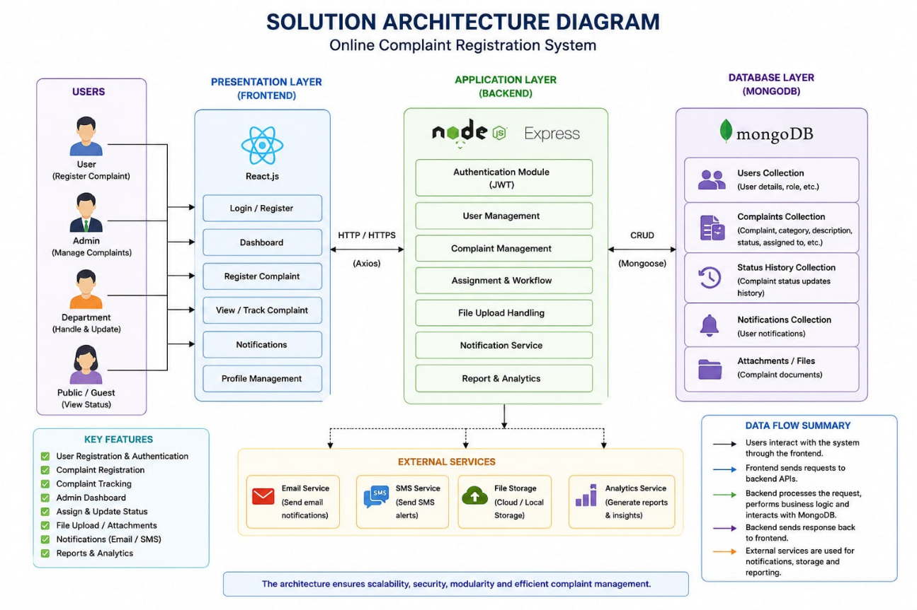

Figure 1: Architecture and data flow of the Online Complaint Registration sample application

